the warhol: Virtual Field Trip Themes

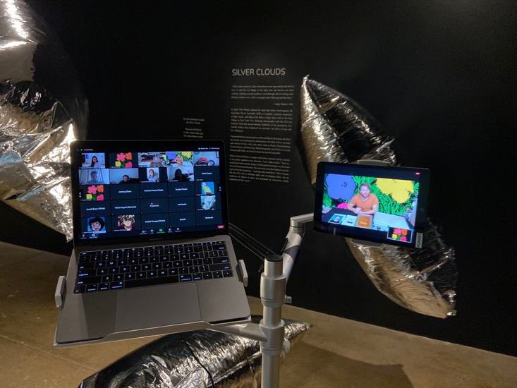

For All Ages:
Prince of Pop: Andy Warhol’s Life and Times
This interactive tour introduces Warhol’s biography and explores highlights of the museum’s permanent collection, including works of art, film, and archival objects.

Recommended Elementary (Grades K-5) Themes:
Coloring Party:
Explore Warhol’s signature use of bright colors, learn about the color wheel and basic color theory, and create your own colorful compositions.

Representation and Abstraction: Rorschach Paintings:
Experience Warhol’s experiments with abstraction, and create your own prints inspired by his Rorschach series.

Recommended Middle School (Grades 6-8) Themes:
Immigration, Imagination, and the American Dream:
Learn how Warhol’s immigrant roots and humble beginnings influenced his career and the iconic artworks he went on to create.

Pop Portraits:
Examine the many ways in which Warhol created portraits throughout his career, from painting and polaroids to silkscreening and selfies.

Recommended High School (Grades 9-12) Themes:
The Art of Repetition:
Silkscreen Printing Learn about Warhol’s innovative use of the photographic silkscreen printing process in his iconic prints and paintings.

Art & Business:
Explore how art and commerce were intertwined throughout Warhol’s career as an artist and entrepreneur.

More of our online lessons exploring Warhol’s life, artistic practice, and legacy can be adapted for a virtual experience or we can tailor an experience specifically for your group.

Additional Materials
Museum educators can also provide Powerpoints, lesson plans, pre-recorded audio and video presentations and select art materials to enhance the learning experience for students who do not have access to the internet.

